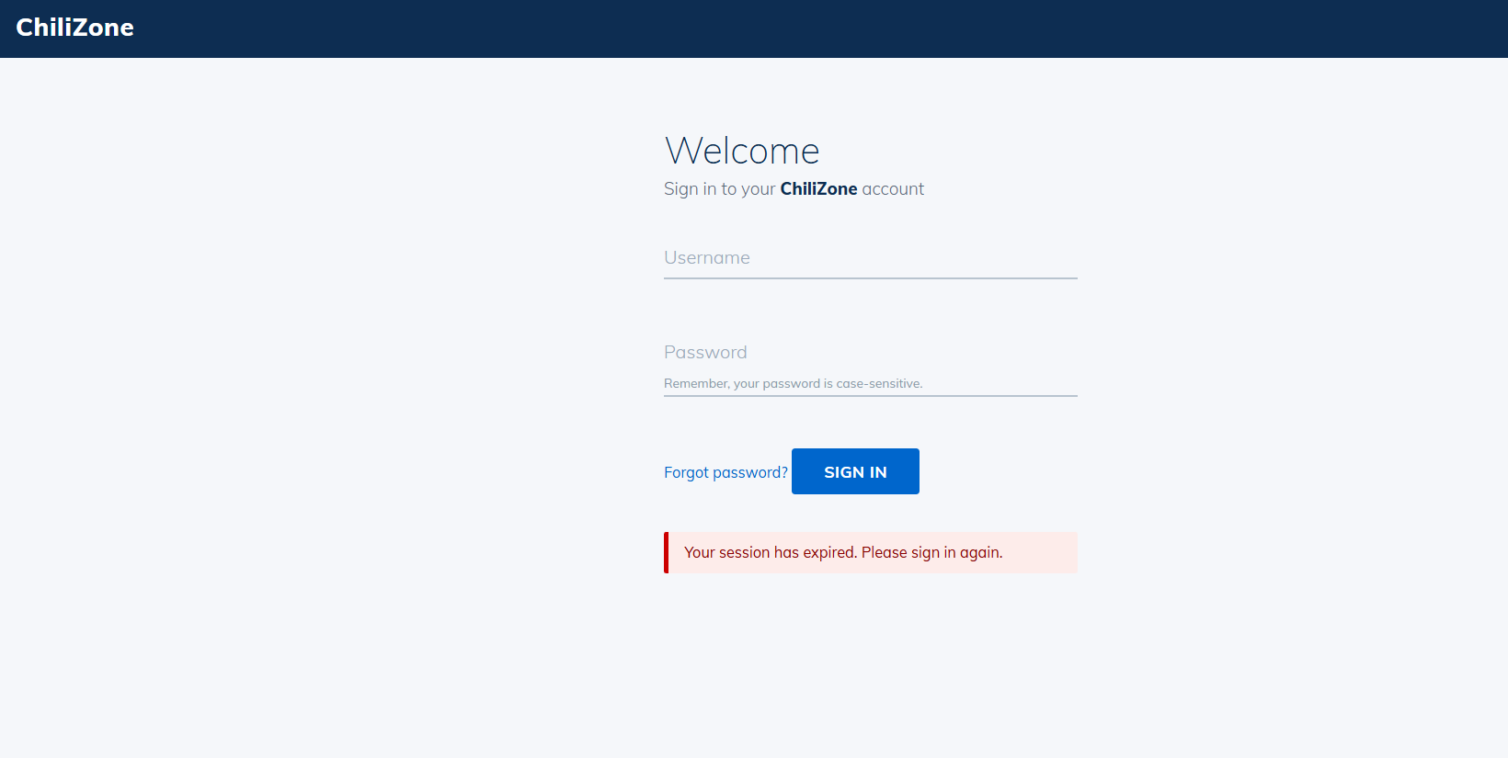
- Enter username and password
- Click Sign In
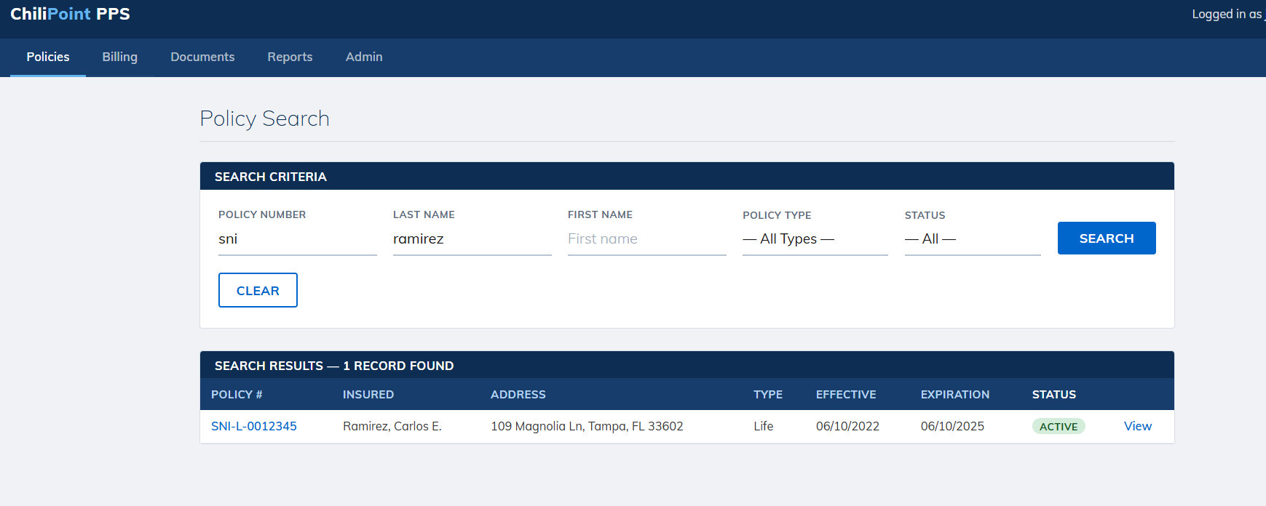

- Type Policy Number
- Click Search
- Click the Policy Number Hyperlink
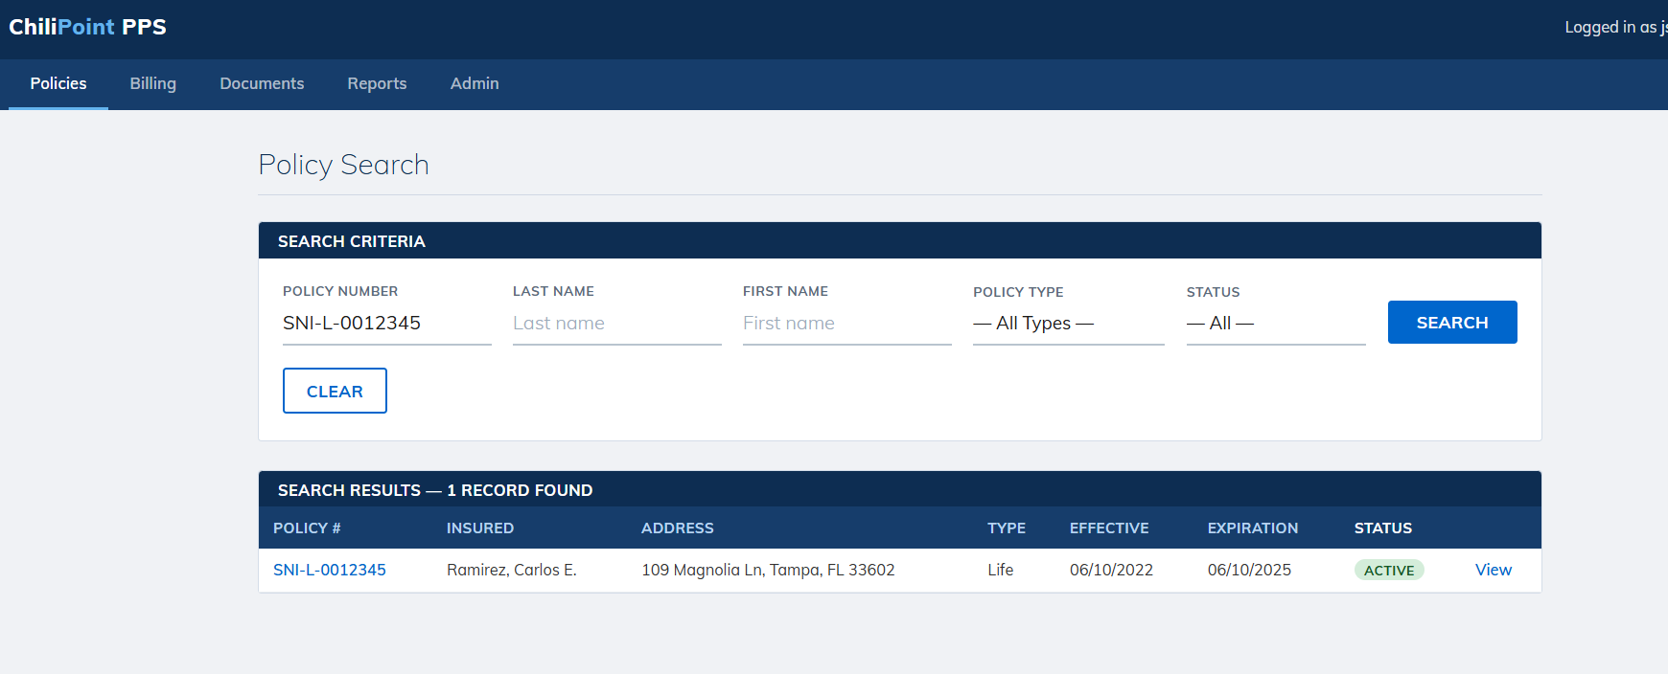

- Select Address Change
- Click Next
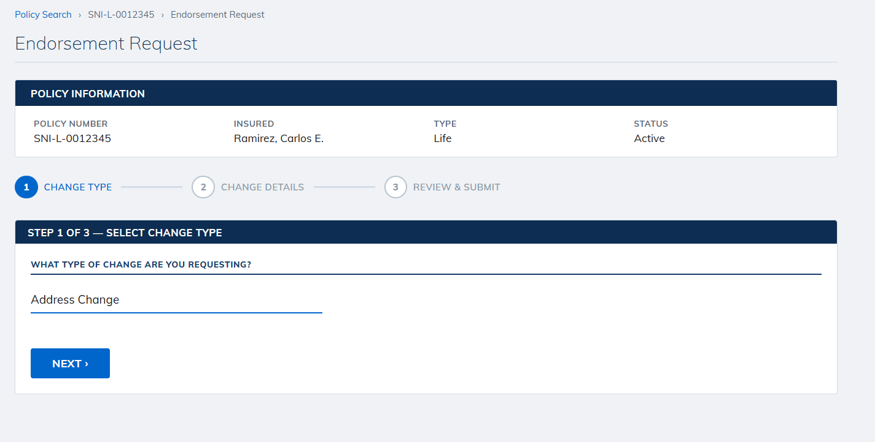
- Enter Address
- Enter Effective Date
- Select Address Type
- Click Next
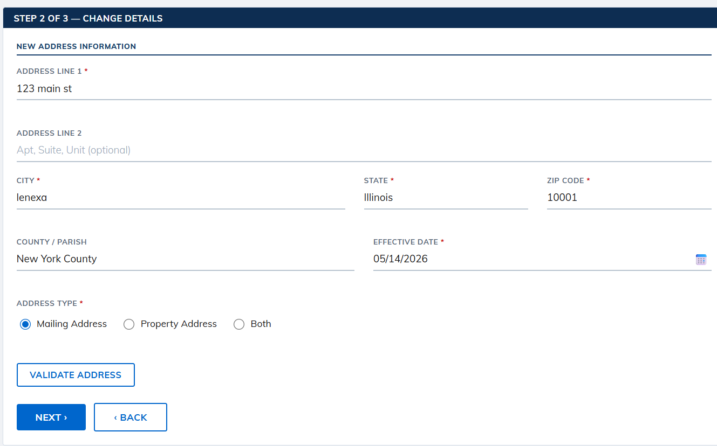
- Check the acknowledgement box
- Click Submit button
- 